SONG JOURNEY
"Luna"
Peso Pluma & Junior H
Thread song — it grows through Modules 1–5
One song, five layers. Each module adds a new skill to this song. Layers 6 and 7 are bonus requinto parts.
Form Requinto intro → verse vamp (with one Dm early on) → the same vamp to the end
Chords F · Am, with Dm swapping in once early on
Lead voice The requinto carries the melody throughout the recording
Rhythm 6/8, felt in 2 — strum the two downbeats each bar
Tempo Practice at 60 BPM. The record moves faster, in 6/8.
LAYER 1 Listen Module 1
"Luna" is in 6/8. Two big beats to a bar, each one splitting into three. Tap along with just the two big beats and let the requinto play the rest.
Do it: Listen to the first verse.
Tap only the 2 big downbeats per bar — try not to tap all six.
You've got it when: You can hum the main hook from memory.
Level up
Listen again. Find the moment Dm swaps in, early in the song.
That’s the only chord change outside F and Am.
LAYER 2 Single Notes Module 2
"Luna" rides two chords — F and Am — so its bassline is just two notes: F (low E string, fret 1) and A (open A string).
Bass roots · low E and open A · 2 big beats each
F F A A
e |--------|--------|--------|--------|
B |--------|--------|--------|--------|
G |--------|--------|--------|--------|
D |--------|--------|--------|--------|
A |--------|--------|--0-----|--0-----|
E |--1-----|--1-----|--------|--------|

Play it: Play 2 big beats per note at 60 BPM, 4 laps.
F rings clean — no buzz.
You've got it when: You can play it from memory at 60 BPM, no stops.
Level up
Play the same 2 roots higher up, on the A string.
F moves to fret 8. A stays open.
Level up · F and A on the A string · 2 big beats each
F F A A
e |--------|--------|--------|--------|
B |--------|--------|--------|--------|
G |--------|--------|--------|--------|
D |--------|--------|--------|--------|
A |--8-----|--8-----|--0-----|--0-----|
E |--------|--------|--------|--------|

LAYER 3 Power Chords Module 3
An unusual twist — this sierreño ballad isn’t usually played with power chords. Optional harder challenge, no score.
Same two notes from Layer 2, now played as power chords — each note plus the note a fifth above it, one shape sliding along the neck. The riff swaps in D5 once, early in the song, before settling into the F5/A5 loop.
F5 · F5 · A5 · A5, with D5 swapped in once early on.
Power-chord loop · low E and A strings · 2 strums per bar, change every 2 bars
D5 F5 F5 A5 A5
e |--------|--------|--------|--------|--------|
B |--------|--------|--------|--------|--------|
G |--------|--------|--------|--------|--------|
D |--7--7--|--------|--------|--------|--------|
A |--5--5--|--3--3--|--3--3--|--7--7--|--7--7--|
E |--------|--1--1--|--1--1--|--5--5--|--5--5--|

Play it: Play 2 downbeat strums per bar at 60 BPM — nothing syncopated.
Change every 2 bars: F5, F5, A5, A5.
You've got it when: The loop runs at 60 BPM, every string ringing clean, no stops.
Level up
Palm-mute 1 lap. Then let the chords ring for 1 lap.
Level up · palm-muted · same chords
D5 F5 F5 A5 A5
e |--------|--------|--------|--------|--------|
B |--------|--------|--------|--------|--------|
G |--------|--------|--------|--------|--------|
D |--7--7--|--------|--------|--------|--------|
A |--5--5--|--3--3--|--3--3--|--7--7--|--7--7--|
E |--------|--1--1--|--1--1--|--5--5--|--5--5--|
PM ─────────────────────────────────────────────

LAYER 4 Pentatonic Solo Module 4
"Luna" lives in F major. Its relative minor is D, so D minor pentatonic Pattern 1 (root D, low E fret 10) is your box — the highest position of the semester.
Four rungs, one Module 4 skill each. Climb them in order.
Rung 1 · Rule of 3
Three starting notes · D minor pentatonic, Pattern 1
D F G
e |----------------------------------|
B |----------------------------------|
G |----------------------------------|
D |----------------------------------|
A |--------------------10------------|
E |--10------13----------------------|

Play it: Improvise over the chord loop.
End every phrase on D.
Rung 2 · The whole box
The whole box · D minor pentatonic Pattern 1 · 10th position
e |--10---------13--------------------|
B |--10---------13--------------------|
G |--10------12-----------------------|
D |--10------12-----------------------|
A |--10------12-----------------------|
E |--10---------13--------------------|

Play it: Run the box up and down, then improvise anywhere inside it, still ending on D.
Rung 3 · Hammer-ons and slides
h = hammer-on. Pick the first note, then tap the higher fret with your ring finger.
/ = slide. Pick once, keep pressing, slide up.
Dress-ups in the box · h = hammer-on, / = slide
C D F G C D D
e |--------------------|--------------------|
B |--------------------|--------------------|
G |------------10h12---|--------------------|
D |--10h12-------------|--10/12-----12------|
A |--------------------|--------------------|
E |--------------------|--------------------|

Play it: Practice each move slowly. The second note must ring clearly.
Then add them to your 3-note phrases.
Rung 4 · Two licks
Lick 1 · down and back up · lands on D
F D C D
e |--13---10--------10-|
B |------------13------|
G |--------------------|
D |--------------------|
A |--------------------|
E |--------------------|

Lick 2 · ascending · lands on D
G A C D
e |--------------------|
B |--------------------|
G |--------------------|
D |------------10---12-|
A |--10---12-----------|
E |--------------------|

Play it: Learn each lick exactly first.
Then change one note or the rhythm.
You've got it when: You’ve climbed all 4 rungs — dress-ups and licks in your solos.
Level up
Slide the whole box down to fret 5 — that’s A minor pentatonic. It fits this vamp too.
Compare how the 2 positions sound.
Level up · lower box · A minor pentatonic Pattern 1, 5th position
e |--5----------8---------------------|
B |--5----------8---------------------|
G |--5-------7------------------------|
D |--5-------7------------------------|
A |--5-------7------------------------|
E |--5----------8---------------------|

LAYER 5 Open Chords Module 5
The whole song as open chords: F (the little shape, xx3211) and Am carry it start to finish as one vamp, with Dm making one brief passing appearance in the song’s opening lines. Same 6/8 pulse — 2 downbeat strums per bar, nothing syncopated.
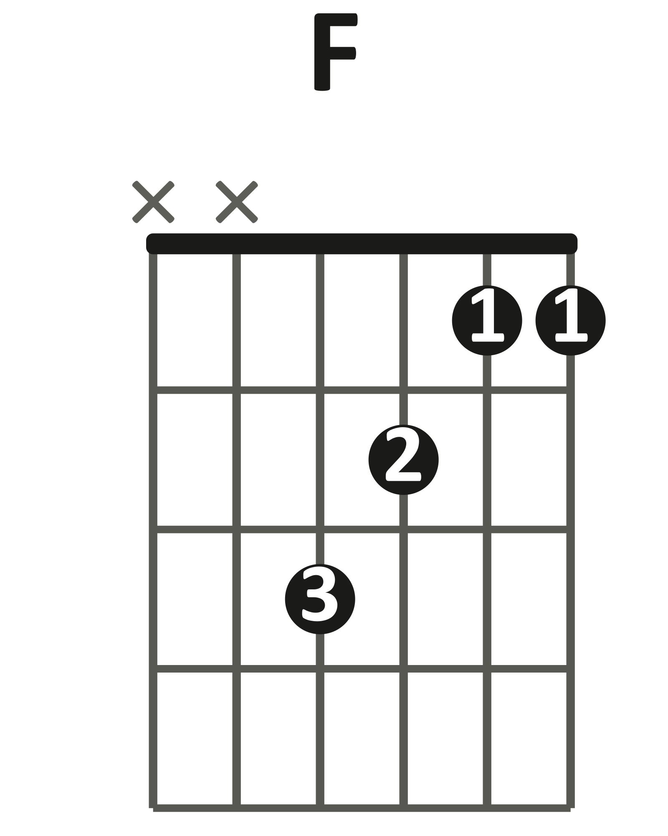  little shape (xx3211) | 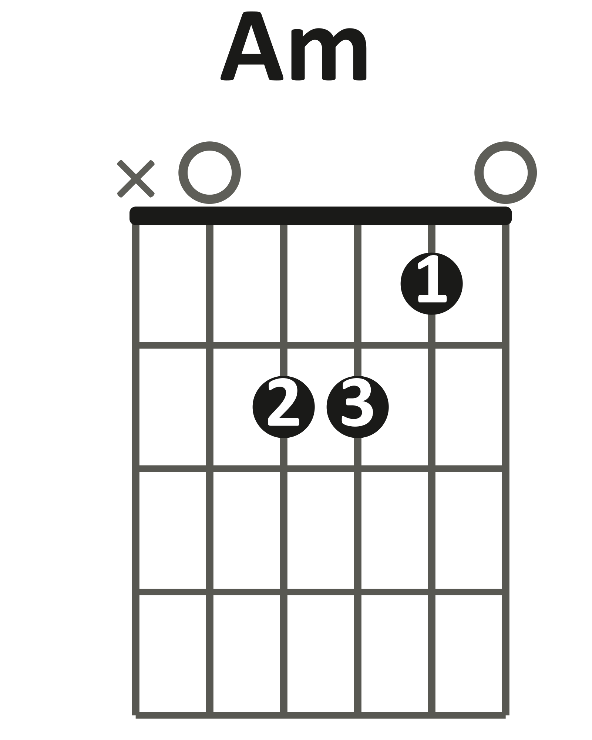 | 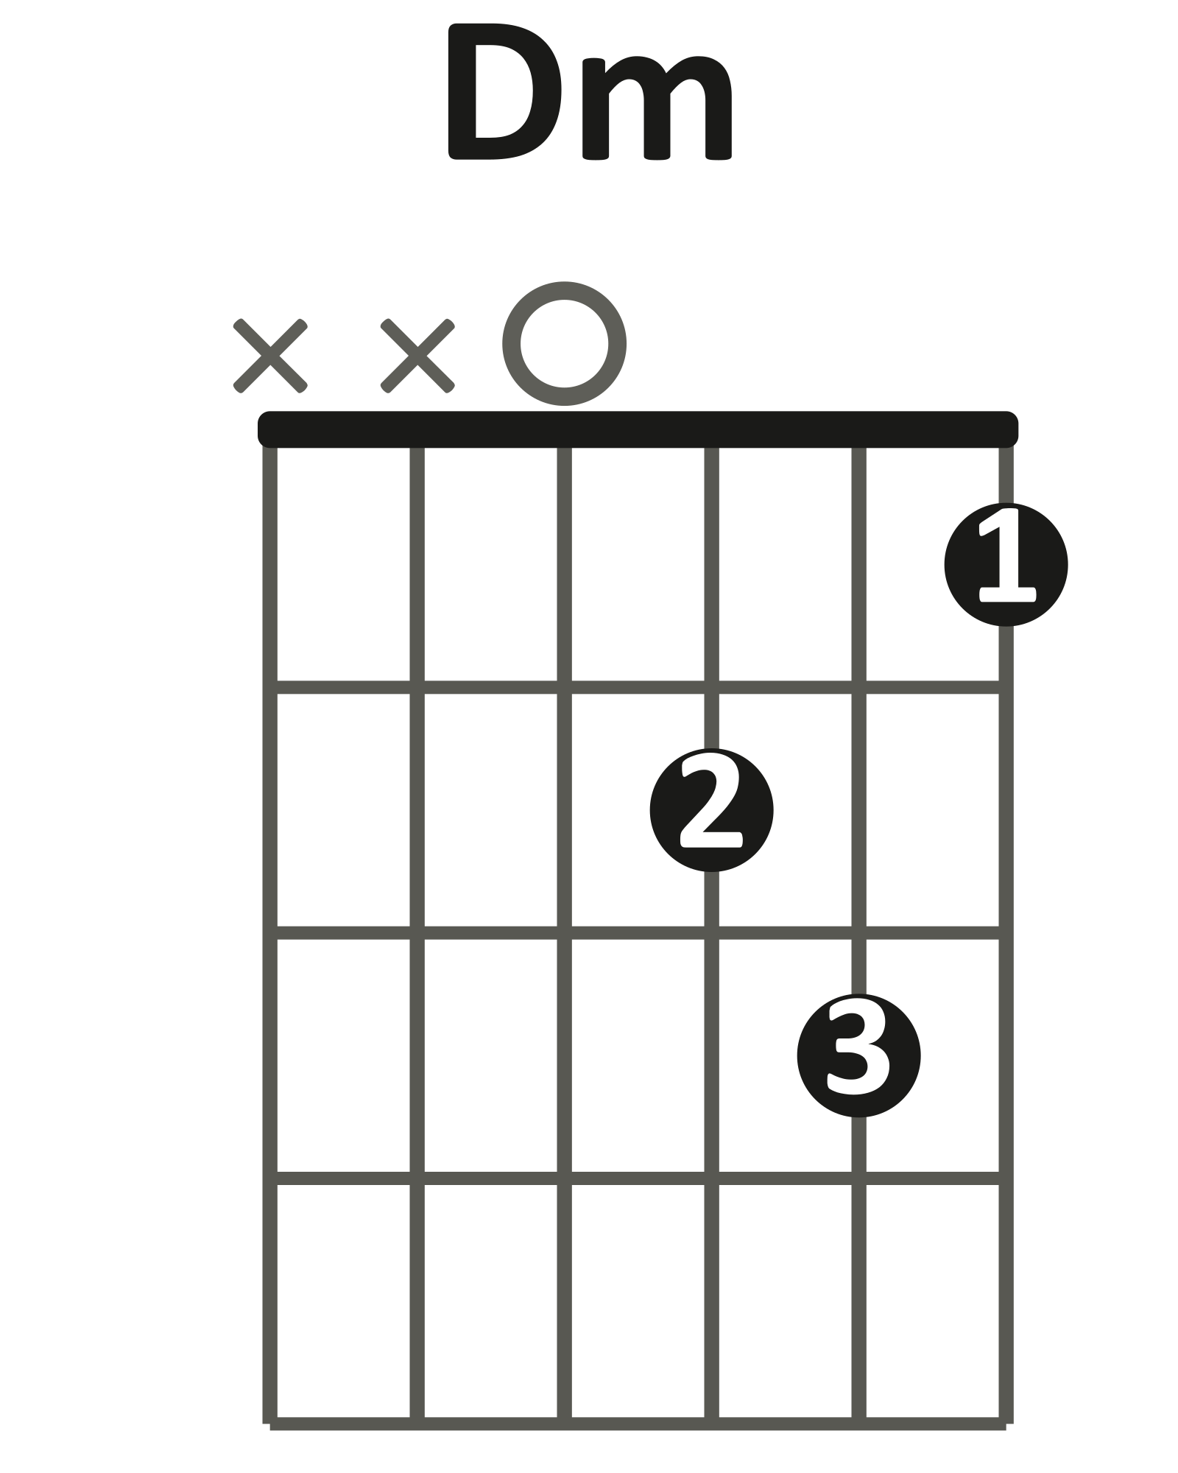

Verse vamp · 2 downbeats per bar · 6/8 felt in 2 · chord change every 2 bars
| F | F | Am | Am |
1 2 1 2 1 2 1 2

Play it: Play down-strums, 2 beats per bar, 4 laps — the change lands right on the downbeat, little F ringing clean.
In the song’s opening lines, swap in Dm once.
You've got it when: The full loop runs at 60 BPM with changes on the beat.
Level up
Play the vamp and hum the melody. Then play 1 full verse without stopping.
Level up · hum the melody · verse vamp
| F | F | Am | Am |
1 2 1 2 1 2 1 2
| F | F | Am | Am | sing
1 2 1 2 1 2 1 2

LAYER 6 Requinto Intro Bonus
Bonus layer — optional harder challenge, no score. Ready whenever you are.
The requinto opens the song with a roll through the little F shape you already know from Layer 5 (xx3211) — just leave the high e string open, and pick the notes one at a time instead of strumming them together.
high e stays open

Intro riff · roll the little F, low to high
(roll ↑)
e |------------0---|
B |----------1-----|
G |--------2-------|
D |------3---------|
A |----------------|
E |----------------|

Play it: Pick D-string fret 3, G-string fret 2, B-string fret 1, then open e — one note at a time, each ringing into the next.
Repeat twice, then let it ring out before the vamp comes in.
You've got it when: The roll is smooth, low to high, and rings into a full F chord at the end.
Level up
Drop the roll in front of the Layer 5 vamp.
Or reverse it — high to low — for a variation.
Level up · roll reversed, high to low
(roll ↓)
e |------0---------|
B |--------1-------|
G |----------2-----|
D |------------3---|
A |----------------|
E |----------------|

LAYER 7 Requinto Lead Bonus
Bonus layer — optional harder challenge, no score. Best once Layer 5 feels steady.
The requinto answers the singer all the way through, weaving its lead line around the same chord shapes you strummed in Layer 5. Part A lives down low, inside your chord shapes. Parts B–D follow the requinto up past fret 12 for the song’s bridge — the highest position on the neck you’ve played all year.
Rung 1 · Part A — verse answers
Keep the chord shape held down and pick single notes out of it — every note is already under your fingers.
little shape (xx3211)

Part A · hold the shape, pick 2 notes per bar, let it ring
F Am
C A F E C A
e |--------|--------|--0-----|--------|
B |--1-----|--------|------1-|--------|
G |------2-|--------|--------|--2-----|
D |--------|--3-----|--------|--------|
A |--------|--------|--------|--------|
E |--------|--------|--------|--------|

Play it: Hold the little F for bars 1–2 — pick C, A, and land on F.
Switch to Am for bars 3–4 — pick the open high e, C, and land on A.
Notes fall on the big beats at 60 BPM; let each one ring into the next.
Rung 2 · Part B — home base at fret 12
For the bridge, slide your hand up until your index finger sits at fret 12 on the high e string — that’s your new home. Pick fret 12, slide up to 13 without letting off pressure, then come back and let 12 ring.
Part B · the slide phrase · / = slide, keep pressing · (12) = let it ring
e |--12/13----12----|--(12)----------|
B |-----------------|----------------|
G |-----------------|----------------|
D |-----------------|----------------|
A |-----------------|----------------|
E |-----------------|----------------|

Play it: Big beats at 60 BPM. Play the 2-bar phrase, then repeat it once more.
Rung 3 · Part C — the climb to fret 17
The bridge peaks on a drumroll of repeated notes at fret 17 — your highest note of the year — then falls: 18, 13, slide down to 12. Count the drumroll with the full 6/8 count, one pick per number. Index at fret 17 (middle finger grabs 18), then hop your index down to 13 and slide it into 12.
Part C · the peak and the fall · drumroll, one pick per number, then 18, 13, slide to 12
e |--17-17-17-17-17-17--|--18---13---13/12--|--(12)------------|
B |---------------------|-------------------|------------------|
G |---------------------|-------------------|------------------|
D |---------------------|-------------------|------------------|
A |---------------------|-------------------|------------------|
E |---------------------|-------------------|------------------|

Play it: Parts B and C single-note first, big beats at 60 BPM, until you can run the whole bridge line twice without stopping.
Rung 4 · Part D — the sierreño sixths
The requinto doubles every bridge note with a partner note on the G string, both ringing together. Pairs: 17 with 17, 18 with 19, 13 with 14, 12 with 12. Pick hits the G string while your middle finger plucks the high e at the same moment.
Part D · the climb, in sixths — sound both strings together
e |--17-17-17-17-17-17--|--18---13---13/12--|
B |---------------------|-------------------|
G |--17-17-17-17-17-17--|--19---14---14/12--|
D |---------------------|-------------------|
A |---------------------|-------------------|
E |---------------------|-------------------|

Part D · coming home, in sixths
e |--12/13----12----|--(12)----------|
B |-----------------|----------------|
G |--12/14----12----|--(12)----------|
D |-----------------|----------------|
A |-----------------|----------------|
E |-----------------|----------------|

Play it: Add the G-string partners slow — 2 clean pairs in a row before you chain the phrase.
You've got it when: You can run the whole bridge line, sixths and all, twice without stopping.
Level up
Stack the layers: open with the Layer 6 roll, play Part A over a verse, play the bridge in sixths, then return to the Layer 5 vamp.
Even better with a partner: one strums, one leads, then trade.
FULL CHORD CHART
"Luna"
Peso Pluma & Junior H
Key F major / D minor (acoustic — no amplifier)
Tempo 128 BPM felt in 2 · 6/8
Rhythm Two downbeat strums per bar; the chord changes every two bars
Form Requinto intro → Verse vamp (with one Dm early on) → the same vamp to the end
Shapes you need

INTRO
| F | F | Am | Am |
The requinto plays the roll alone. Then the vamp starts.
OPENING LINES
| F | Am | F | Am |
Dm appears once early — listen to the record and follow it.
VERSE VAMP
| F | F | Am | Am |
Repeat to the end of the song. Strum the downbeats only — nothing syncopated.
Teaching chart — simplified to match the Journey layers, not a note-for-note transcription. Chord names are what the class plays in standard tuning.

